**Exercise Talend Studio for Data Quality**

* ***Schema Overview Analysis***

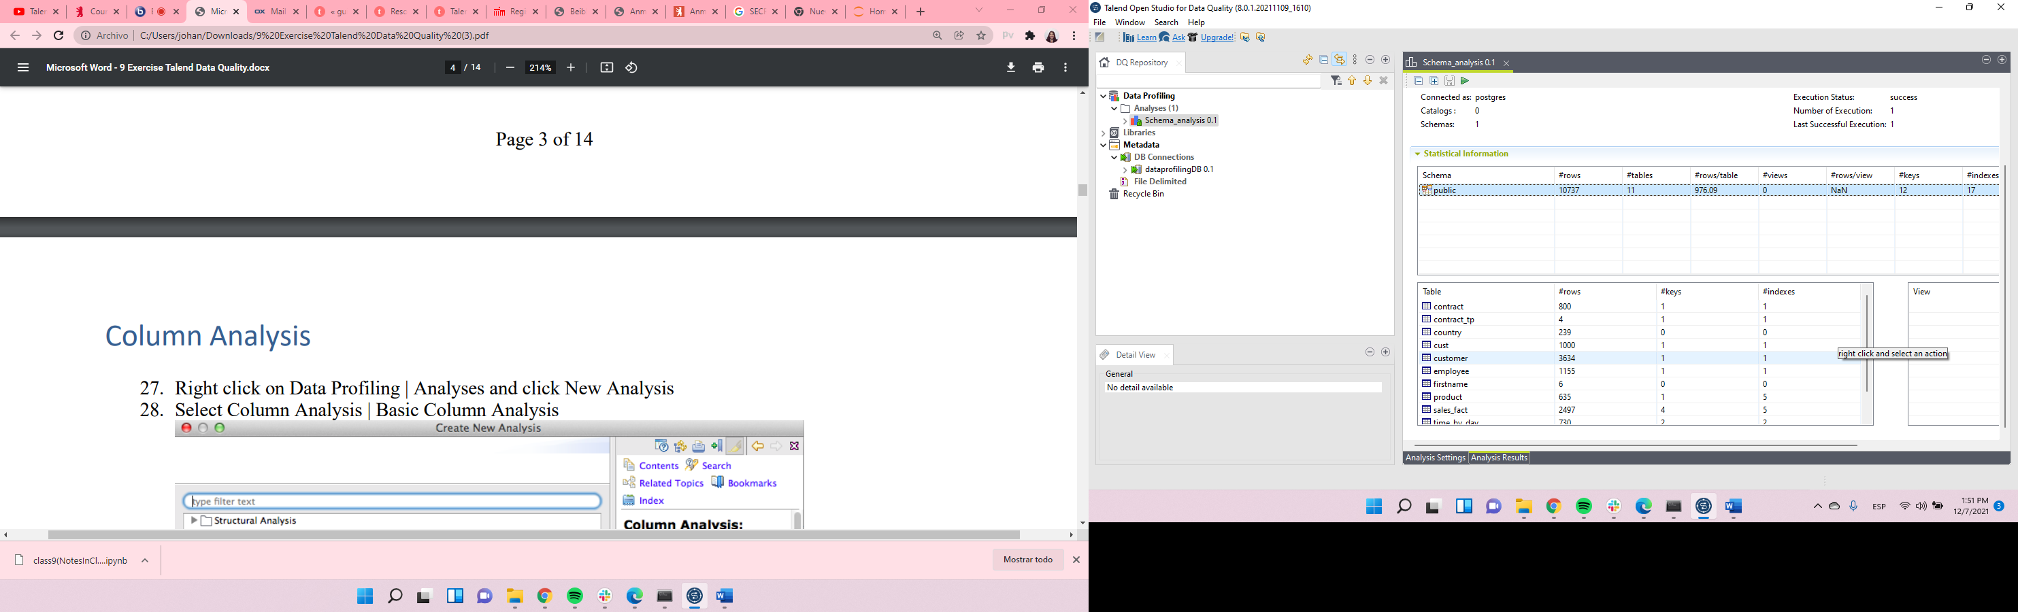

* ***Basic Column Analysis***

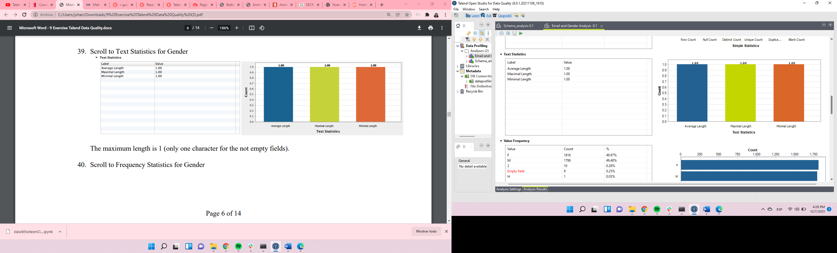

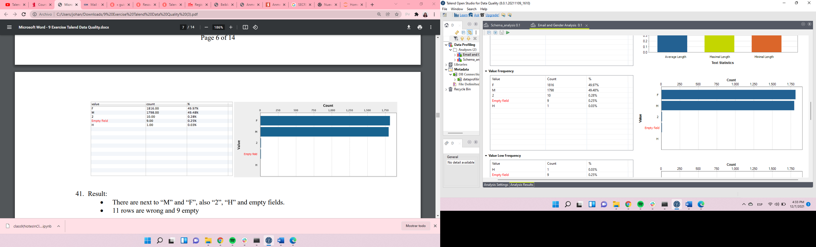

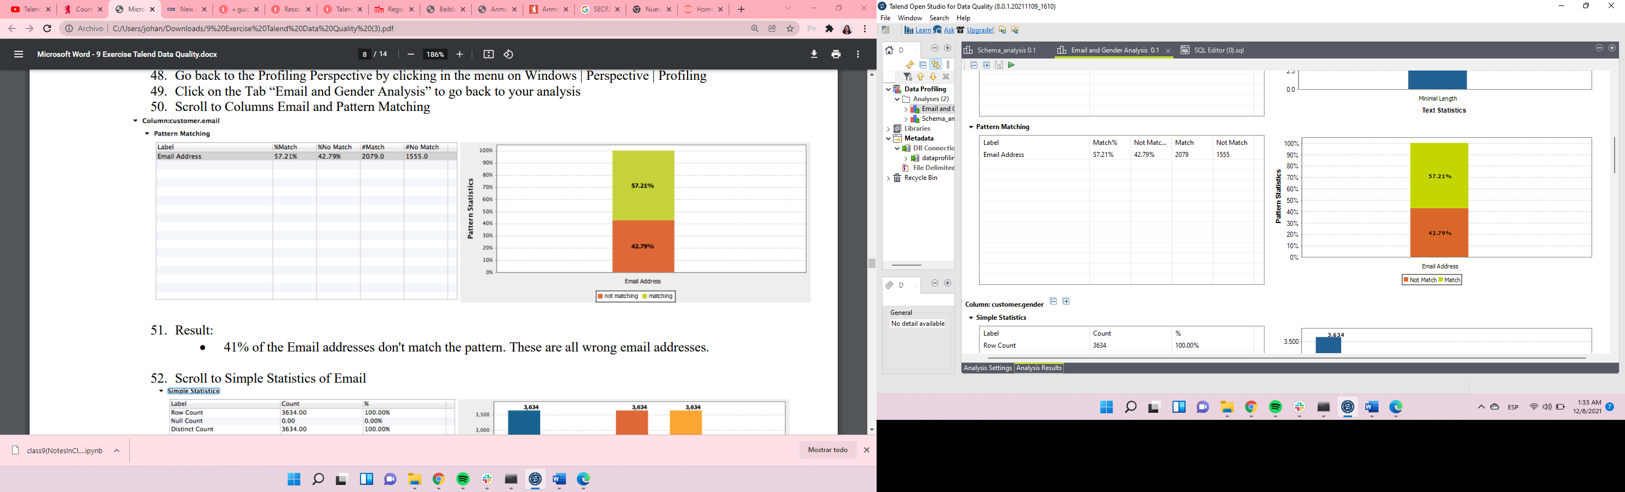

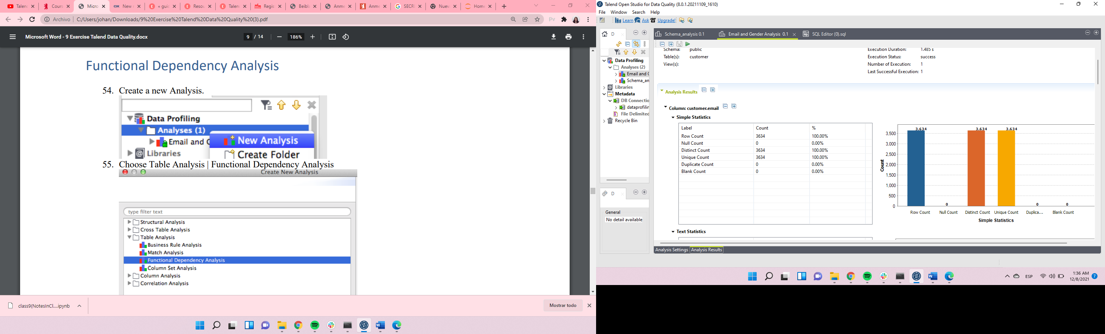

* ***Functional Dependencies Analysis***

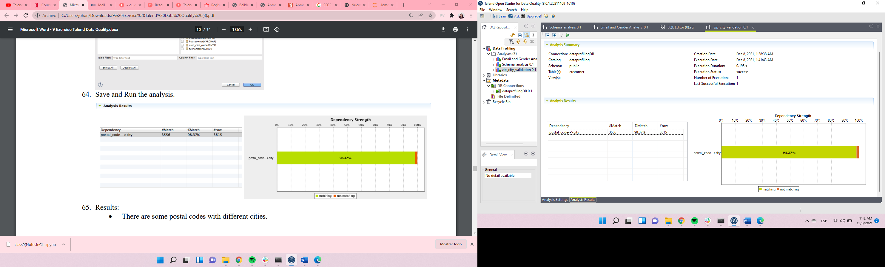

* ***Cross Table Redundancy Analysis.***

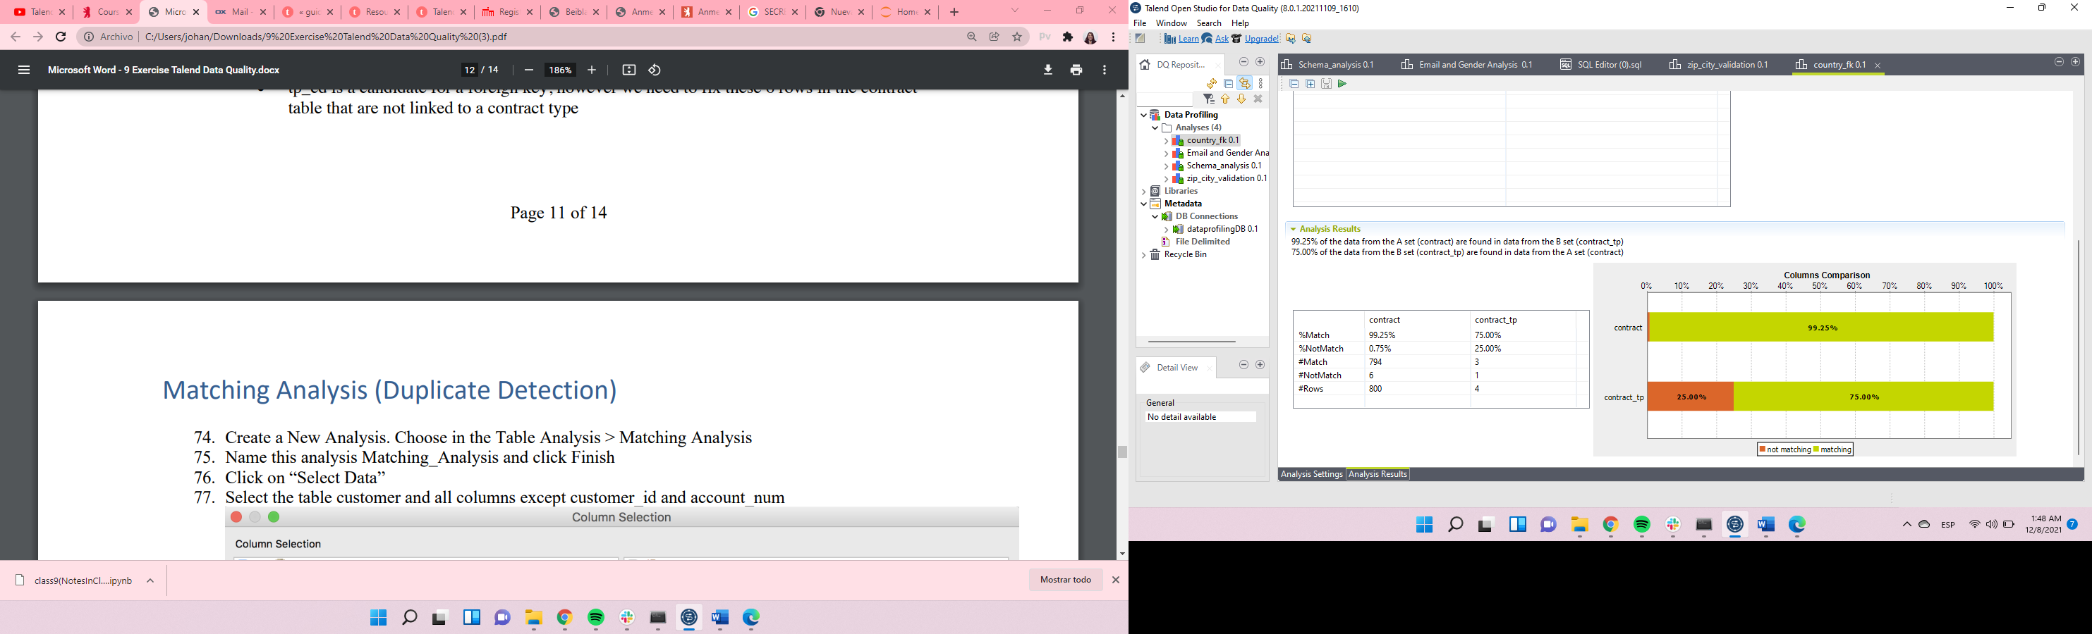

* ***Duplicate detection***

